Passenger Railroad (Amtrak) Station Survey

This is a survey/questionnaire which was adapted from Department of Justice Polling Place Survey and can be used in
assessing accessibility at (Amtrak) railroad stations in your state. (Because this survey is adapted from the DOJ Polling Comments
Place Survey the illustrations are illustrations of typical scenes at polling places).

Railroad Station location: , County

Reviewed by: Date:
SECTION A: GENERAL RAILROAD PASSENGER STATION INFORMATION
A1. What type of building is the railroad station?
___ Stand alone

___ Part of a large complex of building

___Other (describe)
(Focus on access to train)

Other (specify)
A2. What type of parking is used (check all that apply)?

Parking lot Parallel parking on street Angled parking on street

• Note: Parallel parking spots on a street are not required to meet any accessibility guidelines.
A3. What type of parking lot is used?

Paved and clearly marked Paved Gravel Other (specify)
A4. Is the parking lot stable and firm? | Yes No
A5. Is the parking lot well maintained? | Yes No

1

SECTION B: PARKING SPACES

B1. If parking is available, count the total number of parking spaces provided for the railroad station. (Do not count parallel parking spaces on the street; accessibility rules do not apply to such spaces.) Are the minimum number of accessible parking spaces provided, based on the total number of available parking spaces (see table below)?

Total Spaces for Location Required Minimum Number of Accessible Spaces
1-25 ………………………... 1 van-accessible space (96 in.) w/ min. 96 in. wide access aisle

Yes

No

Comments

26-50 ………………………. 1 car-accessible space (96 in.) w/ min. 60 in. wide access aisle + 1 van-accessible space
51-75 ………………………. 2 car-accessible spaces (96 in.) w/ min. 60 in. wide access aisle + 1 van-accessible space
75-100 ……………………. 3 car-accessible spaces (96 in.) w/ min. 60 in. wide access aisle + 1 van-accessible space

• Note: A universal space may be used in place of a van-accessible space. See picture below.

B2. Is there are least one van-accessible parking space provided with an access aisle that is at least 96 in. (8 ft.) wide; or, are universal parking spaces provided with a 132 in. (11 ft.) wide vehicle space and a 60 in. (5 ft.) wide access aisle? [ADA Stds. 4.1.2(5), A4.6]

• Note: If there is a ramp, slope, or other item in the access aisle, please note this in the comment box. [ADA Stds. A4.6.3]

Yes

No

B3. For every car-accessible parking space, does it have its own, or share an adjacent, access aisle that is at least 60 in. (5 ft.) wide? [ADA Stds. 4.6.3]

• Note: If there is a ramp, slope, or other item in the access aisle, please note this in the comment box. [ADA Stds. A4.6.3]
Yes
No

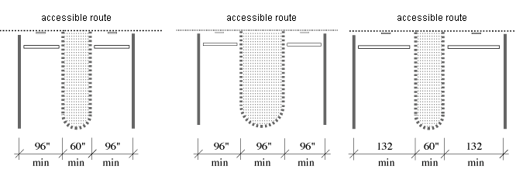
Car-Accessible Spaces Van-Accessible Spaces Universal Spaces

Views of Accessible Parking Spaces Which Share an Access Aisle

B4. For every permanent accessible space, is the access aisle marked and striped? Yes
No

Comments

B5. For every temporary accessible space, is an area 192 inches (16 feet) wide (the size of a van-accessible spot and an access aisle) marked (e.g. with traffic cones)?

• Note: the aisle need not be marked separately from the parking space.
Yes
No

B6. For every angled van-accessible space, is the access aisle on the passenger side of the space? [ADA Proposed Stds. 502.3.4]
Yes
No

B7. For van-accessible spaces, is there vertical clearance (i.e. open space above the area) of at least 98 inches (8 feet, 2 inches) for:

• the vehicle route to the parking space?
• the parking space?
• the access aisle?
• along the vehicle route to the exit? [ADA Stds. 4.6.5]

Yes Yes Yes Yes

No No No No

B7-1. If any of the above are marked no, can the route be cleared by removing or raising low objects?
Yes
No

B7-2. If any of the above are marked no, can the minimum number of van-accessible spaces for that parking lot be relocated?
Yes
No

B8. Are all accessible parking spaces, including the access aisle, relatively level (1:50, or 1 degree max.) in all directions? [ADA Stds. 4.6.3]
Yes
No

B8-1. If no, look for a nearby area that is relatively level which could serve as an accessible parking space with an accessible route to the accessible entrance to voting. Please indicate the location of the alternate area:

B9. Does each accessible parking space have a sign with the symbol of accessibility that is visible when a vehicle is parked in the space? [ADA Stds. 4.6.4]
Yes
No

B10. If there is a curb between the access aisle and the accessible route to the building, is there a curb cut or ramp that meets the following requirements?

Curb cut

Comments

B10-1. Is the ramp surface at least 36 inches wide, excluding flared sides? [ADA Stds. 4.7.3]
Yes
No

B10-2. Is the slope (up or down the ramp)
less than 1:12 or 5 degrees? [ADA Stds. 4.7.2]

Built-up curb ramp
B10-3. Is the ramp surface at least 36 inches wide, excluding flared sides?
Yes Yes
No No

B10-4. If the ramp is a built-up curb ramp (not a curb cut), does it have flared sides or edge protection?

B10-5. If the ramp is a built-up curb ramp, is the slope less than 1:12 or 5 degrees? [ADA Stds. 4.8.2]
Yes

Yes
No

No

Curb ramp showing minimum 36 inch width f ramp section and 1:12 or 5 degrees slope on
ramp section

B11. Is the van-accessible parking space the closest space to the accessible route that is the shortest route to the accessible entrance? [ADA Stds. 4.6.2]

Yes

No

B12. Does each access aisle connect to an accessible route from the parking area to the accessible building entrance? [ADA Stds. 4.6.2]
Yes
No

B12-1. If the accessible entrance is not the main entrance, are there large-print signs guiding voters from the beginning of the accessible route to the accessible entrance?

B13. Does the accessible route cross traffic (a street or driving lane of a parking lot)?

• Note: An accessible route is not considered to cross traffic if the route requires a voter to cross behind parked cars, but does not take the voter across the driving lane of the parking lot.
Yes Yes
No No

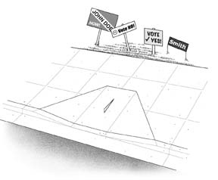B13-1. If yes, is the route clearly designated by a marked crossing? Yes
at

or
No

SECTION C: PASSENGER DROP-OFF AREAS

Answer the following questions if a passenger loading area is provided. Otherwise, proceed to section D.

Comments

C1. Is a relatively level (1:50 or 1 degree max.) access area provided adjacent and parallel to the side of the vehicle pull-up area? [ADA Stds. 4.6.6]
Yes
No

C1-1. If no, look for another relatively level location that is on an accessible route. Please indicate the location of the alternate area:

C2. Is the vehicle space relatively level (1 degree max.) in all directions? Yes
No

C3. Is the area for the access aisle at least 5 feet wide and 20 feet long? [ADA Stds. 4.6.6]

• Note: Unlike an accessible parking space, the surface for the access aisle does not have to be marked or striped.
Yes
No

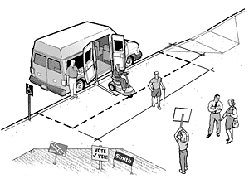
C4. Is the vertical height (clear space above the area) for the drop-off area and the exit at least 114 inches (9 feet 6 inches)? [ADA Stds. 4.6.5]
Yes
No

C5. Is there a curb ramp between the vehicle pull- up area and the accessible route to the accessible entrance? [ADA Stds. 4.6.6]
Yes
No

C5-1. If no, is there another area with a curb ramp connected to an accessible route that could serve as the drop-off area? Please indicate the location of the alternate area:

Comments
C6. If there is a curb ramp, is the slope of the ramp surface (excluding flared sides) less than  1:12 or 5 degrees? [ADA Stds. 4.7.2] | Yes No
C7. Is the width of the curb ramp surface (excluding flared sides) at least 36 inches? [ADA Stds.  4.7.3] | Yes No
C8. Does an accessible route connect the curb ramp to the accessible entrance? [ADA Stds.  4.1.2(1)] | Yes No

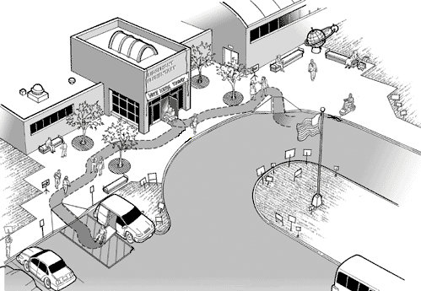
SECTION E: SIDEWALKS AND WALKWAYS
E1. Is there an accessible route from the level area, curb cut, or curb ramp that serves the  van-accessible parking space to the accessible entrance of the building? [ADA Stds. 4.1.2(1), 4.3]  • Note: If the accessible route crosses a vehicular route, a marked crosswalk should be used. | Yes No
E2. If there are public sidewalks or public transportation stops on the polling site, is there an accessible route from those locations to the accessible entrance of the building? [ADA Stds.  4.1.2(1)] | Yes No
E3. Is the accessible route at least 36 inches wide? |  | Yes No
E3-1. If no, does the route narrow to no less than 32 inches wide for less than 2 feet in length (e.g. a doorway)? |  | Yes No
E4. Is the accessible route free of steps and abrupt level changes over ½ inch?  • Note: Level changes ranging from ¼ inch to ½ inch should be angled. |  | Yes No
E5. Where an accessible route crosses a curb, is there a curb ramp or curb cut? |  | Yes No
E5-1. If yes, is the ramp surface at least 36 inches wide, excluding flared sides? [ADA Stds.  4.7.3] |  | Yes No
E5-2. Is the slope (up or down the ramp) less than 1:12 or 5 degrees? [ADA Stds. 4.7.2] |  | Yes No
E6. Are all parts of the accessible route sloped less than 1:20 or 3 degrees? |  | Yes No
E6-1. If yes, please skip question E7 below and proceed to question E8. Otherwise, answer question E7.

Comments

Comments
E7. Check the ramp for the following accessibility features.
E7-1. Is the ramp slope less than 1:12 or 5 degrees? [ADA Stds. 4.8.2] |  | Yes No
E7-2. Is the ramp at least 36 inches wide between the handrails?  E7-3. Are handrails mounted on between 34 and  38 inches above the ramp surface (measure from the top of the handrail)? [ADA Stds. 4.8.5]  E7-3a. Is there a handrail on both sides of the ramp? (Including along a wall if the ramp abuts a wall)  E7-4. Does the ramp have a level landing at the  top and bottom of each ramp section that is at least  60 inches long and the width of the ramp (min. 36 inches)? [ADA Stds. 4.8.4]  E7-5. If the ramp is more than 30 feet long, is a level landing at least 60 inches long provided between every 30 feet of ramp? [ADA Stds. 4.8.4]  • Note: The level landing may be part of the sidewalk or walking surface. | Yes No Yes No  Yes No  Yes No  Yes No | Accessible Ramp Features
E7-6. Is a level landing, 60 inches by 60 inches min., provided where a ramp changes directions? [ADA Stds. 4.8.4]  • Note: Where the ramp leads to a door, this is often a change of direction and a level landing is required. | Yes No

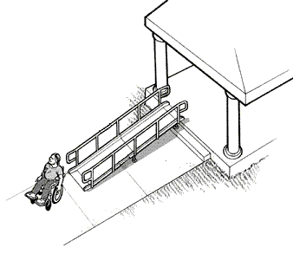

E7-7. If the ramp or landing has a vertical drop-off on either side of the ramp of at least
6 inches, is edge protection provided on both sides (at least 2 inches high, or, if edge protection is not attached to the surface of the ramp, with less than 4 inches between the edge protection and the ramp surface)? [ADA Stds. 4.8.7]

• Note: Where the ramp leads to a door, this is often a change of direction and a level landing is required.
Yes
No

Comments

E8. Is the sidewalk and/or walkway free of objects (e.g. wall-mounted boxes, signs, handrail extensions, trees)?

E8-1. If no, are the bottom edges of the object 27 inches or less above the walkway?

• Note: If the bottom edges of the object are 27 inches or less above the walkway, the object may extend any length into the walkway or sidewalk.

E8-2. If no, are the bottom edges of the object more than 27 inches, but less than 80 inches, above the walkway?
[ADA Stds. 4.4, 4.3.1(3), 4.1.3(2)]

E8-2a. If yes, does the object extend less than 4 inches into the sidewalk or walkway?

Yes Yes

Yes

Yes

No No

No

No

E8-3. If the answer to E8-2 is yes, and the answer to E8-2a is no, can the object be lowered, removed, or modified, or can the route be changed to avoid the object?

Explain:
Yes
No

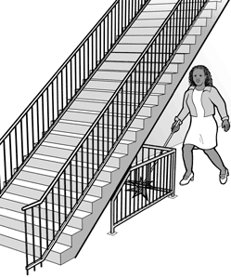

below the stair or installing a cane-

Comments
E9. If exterior stairs are located in the accessible pathway, are the undersides of the stairs enclosed or protected with a cane-detectable barrier so that people who are blind or have low vision will not hit their heads on the underside? [ADA Stds. 4.4.2]  E9-1. If no, can a barrier or enclosure be added below the stair, or can the route be relocated away from the stair? | Yes No  Yes No | When the underside of a stair is open, it
is a hazard to people who are blind or
have low vision. Enclosing the area
E10. Are all objects that hang over the pedestrian routes  80 inches (6 feet 8 inches) or more above the route?  E10-1. If no, can the objects be removed or | Yes No  Yes No | detectable barrier helps the person to stop before hitting her head.
relocated, or can a detectable object (e.g. cone, box) be added below? |  | At least 80 inches above walkway

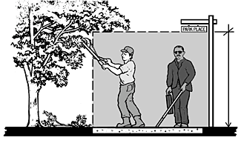

SECTION F: RAILROAD STATION ENTRANCE

F1. Is there are least one entrance connected to an accessible route? Yes

No

Comments

F1-1. If the accessible entrance is not the main entrance, is the accessible entrance unlocked?

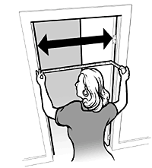
F1-2. If the accessible entrance is not the main entrance, are there large-print signs at the main entrance to direct voters to the nearest accessible entrance?
Yes

Yes
No

No

F2. Does at least one door (or one side of a double leaf door) at the accessible entrance provide at least 32 inches clear passage width when the door is open 90 degrees (see picture to the right for explanation of measurements)?

F2-1. If no, does another entrance have an accessible door; or, are both doors propped open (assuming there is no center dividing beam in the doorway) as a temporary solution?

Yes

Yes

No

No

Open the door 90 degrees. Measure between the edge of the doorway on one side, and the inside edge of the door frame on the other side. This must be at least 32 inches wide.

F3. Can you use the door handle with a closed fist?

Yes

No

• For example, is the handle a lever, pull, or panic bar, and not a thumb lever?

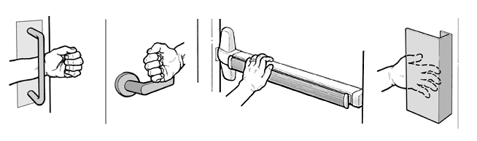
F3-1. If no, is the door propped open as a temporary solution? Yes

Examples of handles and door hardware that can be used without tight grasping, pinching, or twisting.

No

F4. The door is not excessively heavy. Yes
No

Comments

F5. Is the bottom of the door handle mounted between 34 and 48 inches above the finished floor? [ADA Stds. 4.13.9]

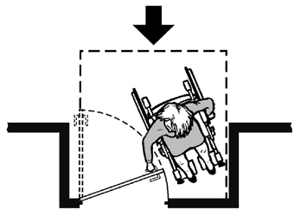
F6. If the door is not automatic or power-operated:
Yes
No

F6-1. Is there 18 inches of level landing clearance on the pull side of the door? [ADA Stds. 4.13.6]

• In other words, measure from the inside of the door frame, next to the handle, along the wall and away from the handle. See pictures on the right.

F6-1a. If no, is the door propped open as a temporary solution?
Yes

Yes
No

No

F7. If there is a raised threshold in the doorway:

F7-1. Is it beveled on both sides? Yes

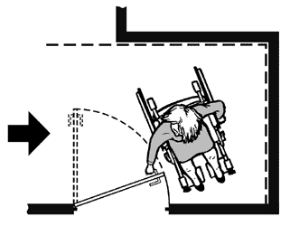
No

F7-2. Is it ½ inch high max.? [ADA Stds. 4.1.6(3)(d)(iii), 4.13.8]

• Note: Raised thresholds of ¾ inch high may be allowed in existing facilities built before the ADA went into effect.
Yes
No

F8. If an entry has a vestibule, is there a 30 inch by 48 inch clear floor space inside the vestibule where a person who uses a wheelchair or scooter can be outside the swing of the hinged door (see pictures below)? [ADA Stds. 4.13.7]
Yes
No

Comments

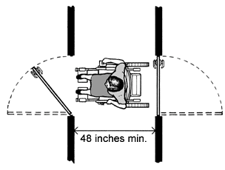

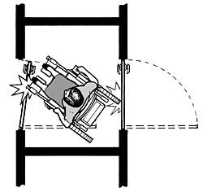
Insufficient space between doors makes the alcove inaccessible.
Minimum alcove depth if both doors open
out is 48 inches.
Minimum alcove depth when door swings
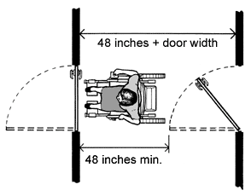
into alcove is 48 inches plus the width of the door.

SECTION G: HALLS AND CORRIDORS (May not be applicable in many stations)

G1. Is there an accessible route, at least 36 inches wide, that connects the accessible entrance to the station or platform area?

• Note: The accessible route may narrow to 32 inches wide for up to 2 feet in length.

Yes

No

Comments

G2. Is the accessible route free of steps and abrupt level changes over ½ inch high? [ADA Stds.
4.1.3(1), 4.3.8]

• Note: Level changes between ¼ and ½ inch should be angled.
Yes
No

G3. At each location on the way to the Ticket Counter or station platform where the accessible route passes through a door or doors, does at least one door meet the following requirements?

G3-1. Is the clear width for the door opening at least 32 inches measured when the door is open to 90 degrees? [ADA Stds. 4.1.3(7), 4.13.5]

• Note: See question F2 for information on measuring the door.

Yes

No

G3-2. Can you use the door handle with a closed fist?

• For example, is the handle a lever, pull, or panic bar, and not a thumb lever?

G3-3. Is there clear floor space on the latch side of the door, as shown in the pictures below?
Yes

Yes
No

No

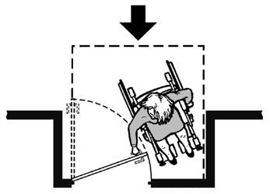
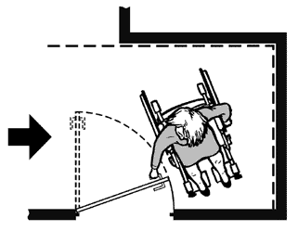
A clear floor space on the latch side of the door (pull side) allows a person using a wheelchair or scooter to pull the door open and enter. The size of the clear floor space varies depending on the direction of approach (shown by the arrows) and the door swing.

For a front approach door, there must be 48 inches For a side approach door, there must be 48 inches min. of clear space min. of clear space from the door frame back. from the door frame back, and 54 inches min. from the hinge side of the
door towards the opposite side of the door frame.

Comments
G3-4. Is there 18 inches of level landing clearance on the pull side of the door? [ADA Stds. 4.13.6]  • Note: See question F6-1 for information on measuring the clearance. | Yes No
G3-5. Is less than 5 pounds of force needed to push or pull open the accessible door? | Yes No
G3-5a. If no, is this a fire door?  • Note: Fire doors may be heavier than other doors.  If you have a spring scale, measure the force needed to open the door. | Yes No

Ramps  G5. Are all parts of the accessible route sloped less than 1:20 or 3 degrees? | Yes No
G5-1. If no, do these parts meet the following requirements for an accessible ramp?
G5-1a. Is the ramp slope less than 1:12 or 5 degrees? [ADA Stds. 4.8.2] | Yes No
G5-1b. Is the ramp width, measured between handrails, at least 36 inches? [ADA Stds. 4.8.3] | Yes No
G5-1c. Are handrails mounted between 34 and 38 inches above the ramp surface? [ADA Stds. 4.8.5]  • Note: Measure from the top of the handrail. | Yes No
G5-1d. If the ramp is more than 30 feet long, is a level landing at least 60 inches long provided between every 30 feet of ramp? [ADA Stds. 4.8.4] | Yes No
G5-1d-1. If no, please measure the height and length of each ramp section.
G5-1e. Does the ramp have a level landing at the top and bottom of each ramp section that is at least 60 inches long and the width of the ramp (min. 36 inches)? [ADA Stds. 4.8.4]  • Note: The level landing may be part of the sidewalk or walking surface. | Yes No
G5-1f. Is a level landing, 60 inches by 60 inches min., provided where a ramp changes directions? [ADA Stds. 4.8.4]  • Note: Where the ramp leads to a door, this is often a change of direction and a level landing is required. | Yes No
G5-1g. If the ramp or landing has a vertical drop-off on either side of the ramp, is edge protection provided on both sides (at least 2 inches high, or, if edge protection is not attached to the surface of the ramp, with less than 4 inches between the edge protection and the ramp surface)? [ADA Stds. 4.8.7] | Yes No

Comments

G6. Are the pedestrian routes leading to or serving the station/platform area free from objects that protrude from the side more than 4 inches into the route and that have a bottom edge higher than 27 inches above the floor? [ADA Stds. 4.4.1]

• Note: these objects may be wall-mounted or free standing. Items to look for include wall- mounted fire extinguishers, light fixtures, coat hooks, shelves, drinking fountains and display cases.

• Note: if the bottom of an object is at or less than 27 inches above the floor, it may extend an unlimited amount from the wall.
Yes
No

Comments

G6-1. If no, list the objects that are a hazard and where they are located.

G6-2. If no, is a detectable object placed on the floor below the hazardous object as a temporary solution?
Yes
No

G7. Are the pedestrian routes leading to or serving the station/platform area free from objects that are overhead and that have a bottom edge lower than 80 inches above the floor?

G7-1. If no, list the objects that are a hazard and where they are located.
Yes
No

G7-2. If no, is a detectable object placed on the floor below the hazardous object as a temporary solution?
Yes
No

G8. If provided, are the interior stairs along the pedestrian routes built so that people who are blind or have visual disabilities cannot hit their heads on the underside (i.e. protected with a cane-detectable warning or a barrier that prevents travel into the area with less than an 80- inch-high clearance)? [ADA Stds. 4.4.2]
Yes
No

SECTION H: TICKET COUNTER (IF THERE IS ONE)

H1. Is there an accessible entrance to the ticket counter area? Yes

No
Comments

H2. Within the station/platform area, is there at least one accessible ticket counter/area? Yes ___ No ___

H3. Is the ticket counter area free from objects that protrude from the side more than 4 inches into the route and that have a bottom edge higher than 27 inches above the floor? [ADA Stds. 4.4]

• Note: these objects may be wall-mounted or free standing. Items to look for include wall- mounted fire extinguishers, light fixtures, coat hooks, shelves and display cases.
Yes
No

H3-1. If no, list the objects that are a hazard and where they are located.

H3-2. If no, is a detectable object placed on the floor below the hazardous object as a temporary solution?
H4. Is the ticket counter area free from objects that are overhead and that have a bottom edge lower than 80 inches above the floor?

H4-1. If no, list the objects that are a hazard and where they are located.
Yes Yes
No No

H4-2. If no, is a detectable object (e.g. cone, box) placed on the floor below the hazardous object as a temporary solution?
Yes
No

H5. Do all rugs and mats along the accessible route have low pile (short fibers)? | Yes No
H6. Are all rugs and mats along the accessible route securely fastened (e.g. with rubber backing)?  • If no, mats may be removed for the day. | Yes No
H7. Is there a way for a passenger to buy ticket in a seated position that is accessible to a person using a wheelchair? | Yes No
H8. Is the ticket counter area well lit? | Yes No
RESTROOMS

The technical accessibility requirements for restrooms are very detailed and lengthy. Thus, we are just asking for a
Simple review of the restroom. Are the doors wide enough for a wheelchair user to get in and out? Yes____ No____

Is there a restroom stall with a wide door and space for a wheelchair? Yes____ No_____

Does the stall have grab bars? Yes___ No____

Any other comments about the restroom? ______________________________________________________________

________________________________________________________________________________________________

Comments

SECTION I: ELEVATORS AND WHEELCHAIR LIFTS

Complete this section if the station/platform utilizes an elevator or wheelchair lift to access the ticket counter area. Otherwise, the survey is complete.

Comments

Elevator
I1. Is an elevator provided to access the station/platform area level? Yes

No

I2. Are the elevator call buttons mounted in an accessible location, with the center of the buttons 42 inches above the floor? [ADA Stds. 4.10.3]
Yes
No

I2-1. Are the elevator call buttons at least ¾ inch in diameter? Yes

No

I2-2. Do the call buttons light up or provide other visual cues to indicate that the elevator has been called?

I3. Are the lights showing the elevator’s direction mounted with the center of the light at least
72 inches (6 feet) above the floor? [ADA Stds. 4.10.4(1)]

I3-1. Do the lights showing the elevator’s direction measure at least 2 ½ inches in some direction?

I4. Does the floor area of the elevator car provide space for a person using a wheelchair to enter, reach the controls, and exit the car?

• Note: Floor dimensions of at least 48 inches by 48 inches may be allowed in existing facilities built before the ADA went into effect.
Yes Yes Yes Yes
No No No No

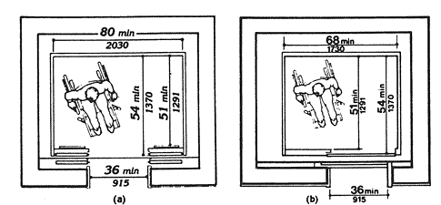

I5. Elevator buttons  I5-1. If the passenger would reach forward to press the elevator floor control buttons, are the highest buttons mounted less than 48 inches above the floor? | Yes No
I5-2. If the passenger would reach sideways, are the highest floor control buttons mounted less than 54 inches above the floor? | Yes No
I5-3. Are raised letter and Braille characters used to identify each floor button and each control? [ADA Stds. 4.10.12] | Yes No
I5-4. Are the control buttons at least ¾ inch in diameter? | Yes No
I6. Are signs mounted on both sides of the elevator door opening to designate the floor, with the center of the sign at least 60 inches above the floor? [ADA Stds. 4.10.5] | Yes No
I6-1. Do the signs have 2 inch min. height raised letters and Braille characters? | Yes No
I7. Is the elevator equipped with audible tones or bells or verbal enunciations that announce each floor as it is passed? [ADA Stds. 4.10.13] | Yes No
Wheelchair Lift  I8. Is a wheelchair lift provided to access the train at the platform level? | Yes No
I9. Is the lift operational at this time? | Yes No
I10. Is the change in level from the floor to the lift surface angled or ramped? | Yes No
I11. Is there are least a 30 inch by 48 inch clear floor space on the wheelchair lift? | Yes No
I12. Does the lift allow a person using a wheelchair to enter, operate, and exit the lift without assistance? | Yes No
I13. Are the controls and operating mechanisms mounted no more than 54 inches above the floor for a side reach, or 48 inches for a forward reach? | Yes No
I14. Are the controls and operating mechanisms usable with one hand without tight grasping, pinching or twisting? | Yes No

Comments

