We’re leading the movement to build a Bicycle-Friendly America for Everyone
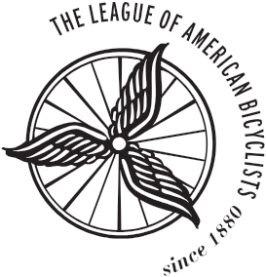

1612 K STREET NW, SUITE 1102, WASHINGTON, DC 20006
| phone 202-822-1333 | fax 202-822-1334 |
WWW.BIKELEAGUE.ORG

March __, 2020

Bicycle Repair is an Essential Business

Dear ____:

The League of American Bicyclists (League) is a national non-profit dedicated to Building a Bicycle Friendly America for Everyone. The League works with hundreds of communities, thousands of businesses, and many bicycle and pedestrian advocacy groups throughout the United States. As states and communities consider which businesses are essential in these times of travel restrictions, place after place is deciding that bicycle retail and repair are essential businesses.

Bicycle retailers and repair shops should be designated as essential businesses:

Bicycling is an essential transportation mode for many Americans, it is low-cost, it is reliable, and it allows social distancing. According to the National Household Travel Survey, half of all trips in the United States are three miles or less, a length that is relatively easy to complete by bike.

Local bike shops support essential bicycle trips through repair services, like auto repair or gas stations.

Bicycling can also provide physical and mental health benefits, while respecting social distancing.

Designating bicycle shops as essential businesses and permitting bicycling for both transportation and light recreation are crucial steps to providing relief to citizens and guidance to officials.

In Connecticut, Illinois and New York, bicycle retailers and repair shops have been designated as essential transportation businesses and allowed to remain open despite other restrictions on business and travel. Cities such as Philadelphia have made similar designations.

The League of American Bicyclists urges you to designate bicycle retailers and repair shops as essential businesses. This designation is important for maintain public health and ensuring that transportation options remain available to people.

Please contact me at ken@bikeleague.org if you have any questions.

Sincerely,

Ken McLeod
Policy Director

